|  |  |
| --- | --- |
| ihome rentals  **Developer Documentation** | Submitted by:   * ARIVANANDHAN PANDIAN * SAMPATH MADALA * SHENG NONG * ZAIFU LIN   COMP-231-080  **PROFESSOR: JAKE NESOVIC** |

Contents

INTRODUCTION 2

HIGH LEVEL ARCHITECTURE 3

PROJECT ARCHITECTURE 3

UML DIAGRAMS 4

DATABASE 12

# INTRODUCTION

* The users can search by using location, type of home, number of bedrooms, and price based on monthly using the price range.
* Once the information is entered, it will display list of houses are available.
* After, user select the house, it will display the entire details of the home, which includes landlord name, contact information such as phone and email.
* User can check google map of the house.
* Also, the user can share this information to a friend by using email.

# HIGH LEVEL ARCHITECTURE

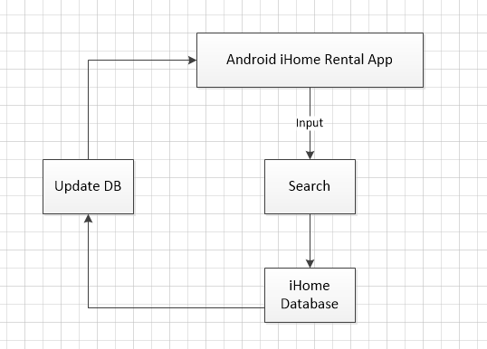

# PROJECT ARCHITECTURE

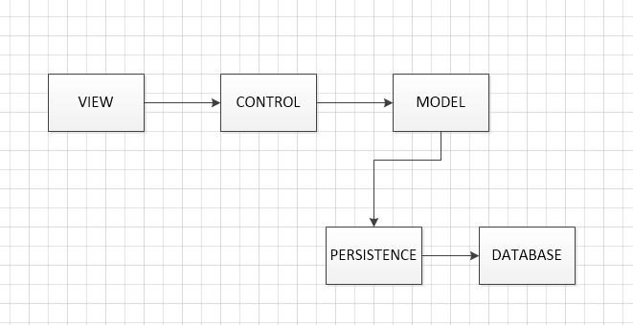

# UML DIAGRAMS



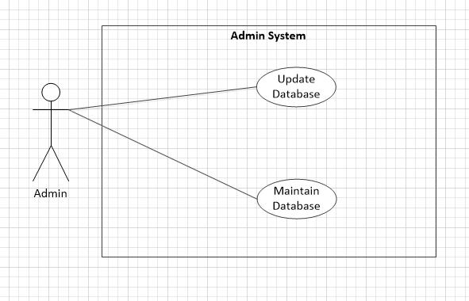

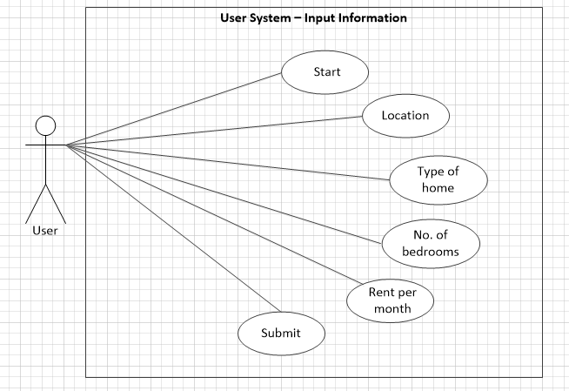

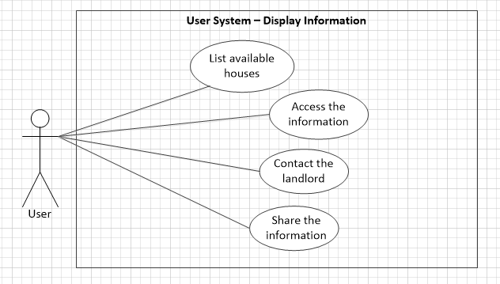

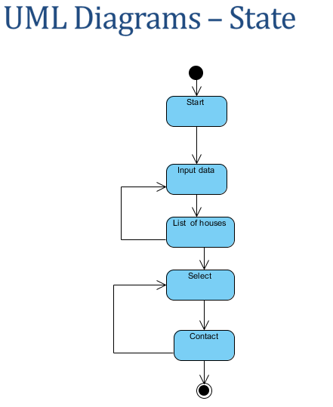

# DATABASE

